Payroll Management System for Information Technology Company

Version 1.0

Revision History

|  |  |  |  |
| --- | --- | --- | --- |
| **Date** | **Version** | **Description** | **Author** |
| 16/12/2019 | 1.0 | Final | Quản Trọng Tú |
|  |  |  |  |
|  |  |  |  |
|  |  |  |  |

Table of Contents

1. Use-Case Name 4

1.1 Brief Description 4

1.2 Actor 4

2. Flow of Events 4

2.1 Basic Flow 4

3. Special Requirements 5

4. Preconditions 5

5. Postconditions 5

6. Extension Points 5

# Use-Case Name

## Brief Description

This use case defines the steps of delete an existing project from the system. Administrator can easily delete a project from the system.

## Actor

Administrator

# Flow of Events

## Basic Flow

The system administrator searches specific project in the project data to delete. The administrator deletes the project data from the application. The system displays the updated total project value in the tables.

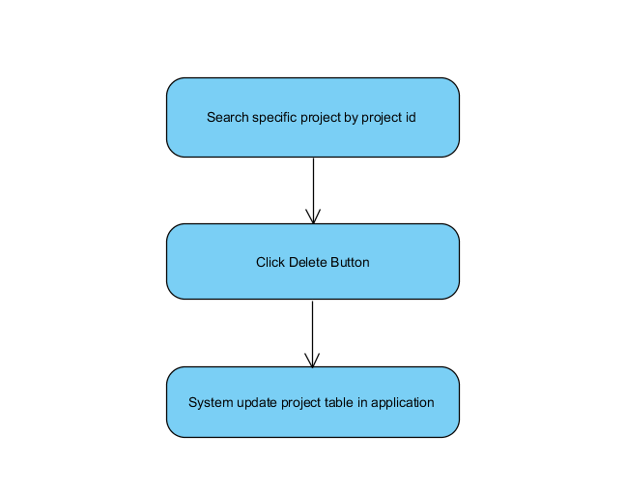

Basic flow of deleting project

# Special Requirements

No Special Requirements.

# Preconditions

* Administrator have to login into application and access Manage Project view.
* Search specific project to check project’s information.

# Postconditions

* Project information displays in a table automatically.

# Extension Points

No extension points.